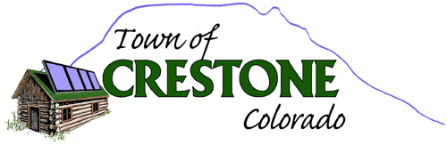

Building Inspector
Request for Proposal
Contract position: Part-time

Duties:
- Must have the ability to perform outdoor activities. Work in a variety of weather conditions, working an average of 3 to 8 hours per month
- Follow all safety practices in operating equipment
- Maintain accurate records, reports, and documentation in coordination with Town Clerk Manager
- Site visits for all building permit applications
- Attend monthly planning commission meetings
- Respond to building inspection phone calls

Requirements:
- Previous municipal and/ or building experience
- Must carry liability insurance and current Colorado drivers’ license
- Have use of a personal vehicle
Preferred:
Applications are available on the town website homepage at townofcrestone.colorado.gov
Please submit a brief letter of intent, resume and references with your completed application to Town Hall either in person, via our secure payment slot at 108 W. Galena Ave; by mail to PO Box 64, Crestone 81131; or via email to crestonetownoffice@gmail.com
The Town of Crestone is an equal opportunity employer and does not discriminate on basis of race, color, religion, sex, national origin, sexual orientation, gender identity, age, disability or genetics. In addition to federal law requirements, the Town of Crestone complies with applicable state laws.
POSTED

